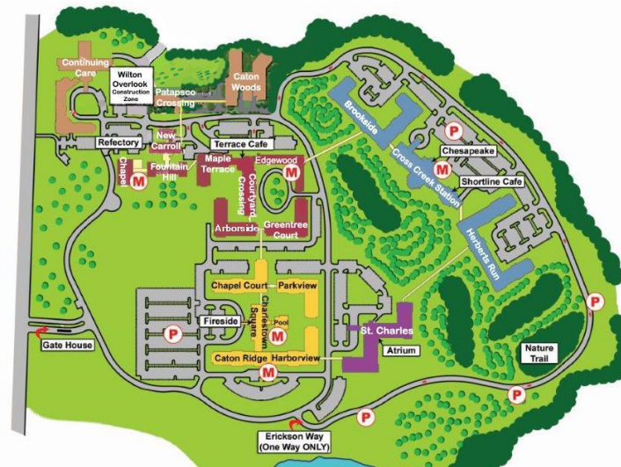

Wayfinding Map for Guests

This is a template in Word to help you create a map that you can either print, insert in an email or attach to an email to help your guest find your new home.

The arrows, smiley face and star can be clicked on and moved anywhere on the map to help your guests find you. You can also turn them by clicking on the  and change their direction. Use the smiley face to show them where to park and the star symbol to show where you live. You can insert any other symbols you prefer to use.

Here is an example script of text you can use to help your guest find you. It might be easiest for them to meet you downstairs in a common area.

Charlestown Retirement Community is located on Maiden Choice Lane off Wilkens Avenue one block inside the beltway. Our address is

7xx Maiden Choice Lane Apt#

Catonsville, MD 21228

Tell the guard at the gate that you are guests of *your name* in *Your Building Name and Apt number*.

Continue to bear *right or left* after the guard house. Follow the signs for ‘*Building Name*’. Best parking is in the smiley face (*named*) parking lot. Enter through *Building* and turn right/Left to get to the elevator. Take it to the *zzz* floor. Turn right/left and proceed to the end of the hall.

.